**COMSATS University Islamabad,**

**Abbottabad Campus**

**SOFTWARE REQUIREMENTS SPECIFICATION   
(SRS DOCUMENT)**

**for**

**Interview Preparation Application**  
Version 1.0

***By***

**Hozefa Hassan Rizvi CIIT/FA20-BSE-019/ATD**

**Ashar Ali CIIT/ FA20-BSE-158/ATD**

**Muhammad Hammad CIIT/ FA20-BSE-031/ATD**

***Supervisor*Mam Sana Malik**

***Bachelor of Science in Computer Science (2020-2023)***

**Table of Contents**

**Revision History 3**

**1.** **Introduction 5**

1.1 Purpose 5

1.2 Scope 5

**2.** **Overall description 6**

2.1 Product perspective 6

2.2 Operating environment 6

2.3 Design and implementation constraints 6

**3.** **Requirement identifying technique 6**

3.1 Use Case Diagram 7

3.2 Use Case Description 8

**4.** **Functional Requirement 12**

**5.** **Non-Functional Requirement 15**

**7.** **Project Gantt Chart 15**

**8.** **References 15**

**Revision History**

|  |  |  |  |
| --- | --- | --- | --- |
| **Name** | **Date** | **Reason for changes** | **Version** |
|  |  |  |  |
|  |  |  |  |

**Application Evaluation History**

|  |  |
| --- | --- |
| **Comments (by committee)**  **\*include the ones given at scope time both in doc and presentation** | **Action Taken** |
|  |  |
|  |  |

**Supervised by**

**Mam Sana malik**

Signature______________

**Introduction**

We’re going to present a detailed description of **the “Interview preparation Application”**. It will explain the purpose and features of the application, the interfaces of the system, what the system will do, the constraints under which it must operate and how the system will react to external stimuli. This document is intended for both the stakeholders and the developers of the system and will be liable for the approval or disapproval of the project by the final year project committee.

**Purpose**

The purpose of this Software Requirements Specification (SRS) document is to outline the detailed requirements for the development of the **"Interview Preparation Application."** This application is targeted specifically for software engineering graduates, providing them with a comprehensive platform to prepare for job interviews. The application aims to bridge the gap between academic learning and the practical skills needed for successful interviews. By describing the specific requirements, this document will serve as a guide for the development team to ensure the successful implementation of the application.

**Scope**

The **"Interview Preparation Application"** is a comprehensive platform designed to enhance the interview preparation experience for software engineering graduates. It serves as a central hub for users to access a rich repository of interview-related resources, engage with industry experts, participate in community discussions, and check their nonverbal communication capabilities by mock interview. By providing an intuitive and user-friendly interface, the application aims to streamline the interview preparation process and equip users with the necessary skills and confidence to excel in their job interviews.

**Overall description**

**Product perspective**

We are going to deploy an entirely new application; this work hasn’t been done before. Emotion Detection has been used in many other categories, but we are going to use it for nonverbal communication. And we have searched for an application like this. There are applications like Huru and Mangtas, but they’re paid and not specifically focusing on nonverbal communication betterment.

**Operating environment**

**OE-1:** This system shall operate on the Android Phones working on Android 10.0 and above. And a student of COMSATS University Islamabad, Abbottabad Campus.

**Design and implementation constraints**

**CO-1:** Our application will use Firebase Database as a database provided by Google.

**CO-2:** Our application will use the OpenCV library for implementing the Emotion Detection in the application.

**CO-3:** Our application will utilize React Native as the primary framework for application development.

**Requirement identifying technique.**

**Brainstorming**: We have sat in a team and ask all the members to give their opinion on this system.

**Observation:** We observed by our own experience and our seniors that this type of application should be deployed to help the graduates.

**Use case diagram:**

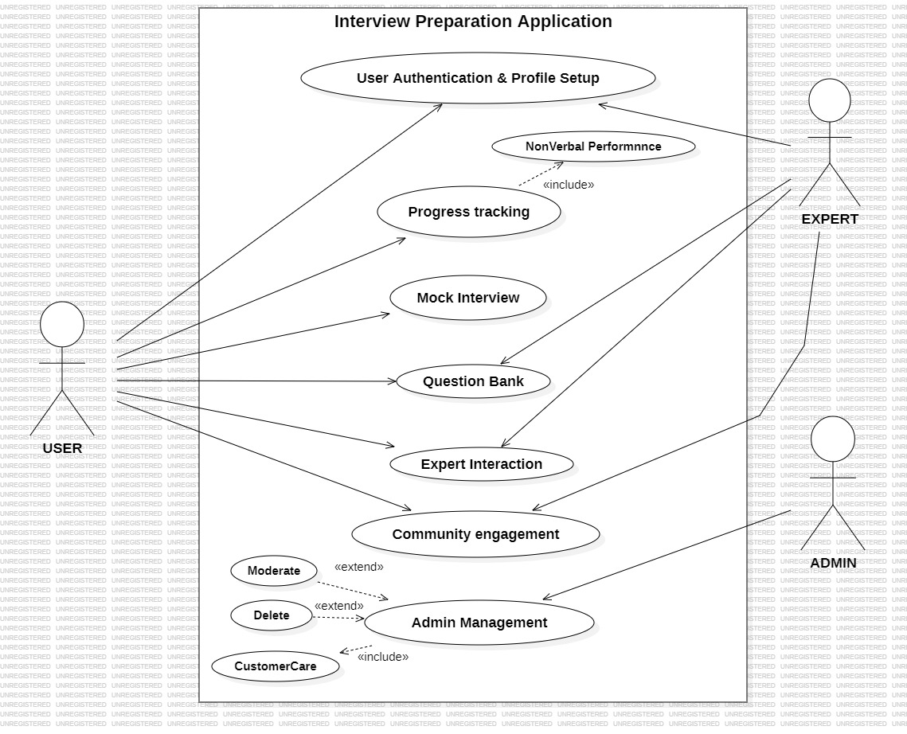

**Use case description:**

|  |  |
| --- | --- |
| **Use Case ID:** | UC-1 |
| **Use Case Name:** | User Authentication and Profile Setup |
| **Actors:** | **Primary Actor:** User, **Secondary Actor:** Expert |
| **Description:** | The user creates a profile and sets up their interview preparation goals. |
| **Trigger:** | The user clicks on the "Signup" button. |
| **Preconditions:** | The user must not be already registered. |
| **Postconditions:** | The user has a valid email address. |
| **Normal Flow:** | 1. The user opens the application and is prompted with the login screen. 2. The user enters their registered email address and password. 3. The application verifies the credentials and grants access to the user's account. 4. The user is directed to their dashboard where they can set up their profile by providing additional information such as their educational background and technical interests. |
| **Alternative Flows:** | None |
| **Exceptions:** | If the user enters an incorrect email or password, the application displays an error message and prompts the user to retry |
| **Business Rules** | The user must provide the correct login credentials that match the information stored in the application's database. |
| **Assumptions:** | The user has a stable internet connection during the authentication process. |

|  |  |
| --- | --- |
| **Use Case ID:** | UC-2 |
| **Use Case Name:** | Progress Tracking |
| **Actors:** | User |
| **Description:** | This use case involves tracking the user's progress and performance within the Interview Preparation Application |
| **Trigger:** | The user accesses the progress tracking feature within the application. |
| **Preconditions:** | The user must not be already registered. |
| **Postconditions:** | The user gains insights into their strengths and areas for improvement. |
| **Normal Flow:** | 1. The user navigates to the progress tracking section within the application. 2. The application compiles and displays the user's performance data, including the areas they have mastered and those requiring further attention. 3. The user can review the data and plan their future preparation strategies accordingly. |
| **Alternative Flows:** | None |
| **Exceptions:** | If the application fails to retrieve the user's progress data, it displays an error message and suggests the user try again later. |
| **Business Rules** | The progress tracking feature relies on accurate data collection from the user's interactions within the mock interview. |
| **Assumptions:** | The user has given the mock interview. |

|  |  |
| --- | --- |
| **Use Case ID:** | UC-3 |
| **Use Case Name:** | Mock Interview |
| **Actors:** | User |
| **Description:** | This use case involves the user conducting a mock interview using the Interview Preparation Application to improve their interview skills and gain confidence. |
| **Trigger:** | The user selects the mock interview option from the application's menu. |
| **Preconditions:** | The user must have completed the user authentication and profile setup process. |
| **Postconditions:** | The user receives feedback on their mock interview performance and areas for improvement. |
| **Normal Flow:** | 1. The user navigates to the mock interview section in the application. 2. The user begins the mock interview, which is recorded by the application. 3. The application analyses the user's performance based on facial expressions, body language, and verbal responses. 4. The user receives feedback on their confidence levels and non-verbal communication skills. |
| **Alternative Flows:** | None |
| **Exceptions:** | If the user experiences technical difficulties during the mock interview, the application displays an error message and prompts the user to try again. |
| **Business Rules** | The mock interview feature relies on the user's device camera and microphone functionality. |
| **Assumptions:** | The user has a device with a functional camera and microphone for the mock interview. |

|  |  |
| --- | --- |
| **Use Case ID:** | UC-4 |
| **Use Case Name:** | Question Bank |
| **Actors:** | **Primary Actor:** User, **Secondary Actor:** Expert |
| **Description:** | This use case involves users accessing a comprehensive question bank within the Interview Preparation Application to explore various interview questions and prepare effectively. |
| **Trigger:** | The user selects the question bank option from the application's menu. |
| **Preconditions:** | The user must have completed the user authentication and profile setup process. |
| **Postconditions:** | The user gains access to a wide range of interview questions and answers for practice and preparation. |
| **Normal Flow:** | 1. The user navigates to the question bank section in the application. 2. The application displays a categorized list of interview questions based on different software engineering roles and topics. 3. The user selects a specific category or topic to view related interview questions and their suggested answers. |
| **Alternative Flows:** | None |
| **Exceptions:** | If the question bank section experiences technical issues, the application displays an error message and prompts the user to try again later. |
| **Business Rules** | The question bank content is regularly updated and reviewed for accuracy and relevance. |
| **Assumptions:** | The user has a stable internet connection to access the question bank content in the application. |

|  |  |
| --- | --- |
| **Use Case ID:** | UC-5 |
| **Use Case Name:** | Expert Interaction |
| **Actors:** | **Primary Actor:** User, **Secondary Actor:** Expert |
| **Description:** | This use case involves users interacting with experts who have given interview or have some knowledge about interview within the Interview Preparation Application to seek guidance, advice, and valuable insights for their interview preparation. |
| **Trigger:** | The user selects the expert interaction option from the application's menu. |
| **Preconditions:** | The user must have completed the user authentication and profile setup process. |
| **Postconditions:** | The user gains valuable advice and insights from experienced industry professionals. |
| **Normal Flow:** | 1. The user navigates to the expert interaction section in the application. 2. The user selects a specific expert to interact with and sends a request or message seeking guidance. |
| **Alternative Flows:** | None |
| **Exceptions:** | If an expert is unavailable or unresponsive, the application provides alternative options or prompts the user to try connecting with other available experts. |
| **Business Rules** | The expert interaction feature respects the privacy and availability settings of industry experts within the application. |
| **Assumptions:** | The user sends professional and courteous messages to the industry experts, fostering a respectful and informative interaction. |

|  |  |
| --- | --- |
| **Use Case ID:** | UC-6 |
| **Use Case Name:** | Community Engagement |
| **Actors:** | **Primary Actor:** User, **Secondary Actor:** Expert |
| **Description:** | This use case involves users participating in the community engagement activities provided within the Interview Preparation Application, such as discussion forums, sharing experiences, and providing feedback. |
| **Trigger:** | The user selects the community engagement option from the application's menu |
| **Preconditions:** | The user must have completed the user authentication and profile setup process. |
| **Postconditions:** | The user actively engages in informative discussions, shares experiences, and provides feedback to other users |
| **Normal Flow:** | 1. The user navigates to the community engagement section in the application. 2. The application displays various discussion topics, threads, or forums related to software engineering interviews and preparation strategies. 3. The user actively participates by sharing experiences, providing feedback to other users, and contributing to ongoing discussions. |
| **Alternative Flows:** | None |
| **Exceptions:** | If the community engagement section experiences technical issues, the application displays an error message |
| **Business Rules** | The community engagement feature encourages constructive and respectful interactions among users, fostering a supportive and informative community environment. |
| **Assumptions:** | The user respects the community guidelines and code of conduct, promoting positive and beneficial engagement within the community. |

|  |  |
| --- | --- |
| **Use Case ID:** | UC-7 |
| **Use Case Name:** | Admin Management |
| **Actors:** | Admin |
| **Description:** | This use case involves the administrator managing and overseeing the operations and content within the Interview Preparation Application, including user activities, expert interactions, and community engagement. |
| **Trigger:** | The admin accesses the application's admin management portal. |
| **Preconditions:** | The admin accesses the application's admin management portal. |
| **Postconditions:** | The admin successfully monitors and moderate’s user activities, expert interactions, and community engagement. |
| **Normal Flow:** | 1. The admin logs into the admin management portal using the provided credentials. 2. The application provides a comprehensive overview of user activities, expert interactions, and community engagement data. 3. The admin moderate’s user-generated content, resolves disputes, and ensures adherence to community guidelines and standards. |
| **Alternative Flows:** | None |
| **Exceptions:** | If the admin encounters technical issues while accessing the admin management portal, the application displays an error message and prompts the admin to try again later. |
| **Business Rules** | The admin management feature grants the administrator the authority to enforce application guidelines and standards, ensuring a safe and supportive environment for all users. |
| **Assumptions:** | The admin performs their duties diligently and impartially, fostering a secure and professional environment within the application. |

**Functional Requirements**

|  |  |
| --- | --- |
| Identifier | FR-01 |
| Title | User Authentication and Profile Setup |
| Requirement | Users must be able to register and create a profile with their personal and educational details |
| Source | Stakeholder Interview |
| Rationale | Users need a secure and personalized experience |
| Dependencies | User database connectivity |
| Priority | High |

|  |  |
| --- | --- |
| Identifier | FR-02 |
| Title | Progress Tracking |
| Requirement | The system should track and display the user's progress in various modules and mock interviews |
| Source | Business Analyst Specification |
| Rationale | Users need to monitor their performance and identify areas for improvement |
| Dependencies | Module completion functionality |
| Priority | High |

|  |  |
| --- | --- |
| Identifier | FR-03 |
| Title | Mock Interview |
| Requirement | The system should simulate a real job interview and analyse the user's performance based on confidence levels and non-verbal communication |
| Source | Expert Recommendation |
| Rationale | Users should have a platform to practice interviews and receive feedback |
| Dependencies | Non-verbal performance analysis |
| Priority | High |

|  |  |
| --- | --- |
| Identifier | FR-04 |
| Title | Question Bank |
| Requirement | The system must provide a diverse set of interview questions covering various software engineering topics |
| Source | User Requirement Analysis |
| Rationale | Users should have access to a comprehensive repository of interview questions for preparation |
| Dependencies | Database of interview questions |
| Priority | High |

|  |  |
| --- | --- |
| Identifier | FR-05 |
| Title | Expert Interaction |
| Requirement | Users should be able to interact with professionals and seek guidance for interview preparation |
| Source | Market Research |
| Rationale | Users can benefit from the insights and experiences of experts in the field |
| Dependencies | Expert availability |
| Priority | Medium |

|  |  |
| --- | --- |
| Identifier | FR-06 |
| Title | Community Engagement |
| Requirement | The system should facilitate a community platform for users to share experiences, tips, and provide feedback |
| Source | User Feedback |
| Rationale | A supportive community can enhance users' interview preparation journey |
| Dependencies | User participation |
| Priority | Medium |

|  |  |
| --- | --- |
| Identifier | FR-07 |
| Title | Admin Management |
| Requirement | The system should enable administrators to manage user accounts, monitor content, and ensure a positive user experience |
| Source | System Requirement Document |
| Rationale | Admins need tools to maintain a safe and informative environment |
| Dependencies | Admin control panel |
| Priority | High |

**Non-Functional Requirements**

1. **Usability:**

* **USR-1:** The Interview Preparation Application shall have an intuitive and user-friendly interface to facilitate easy navigation and access to features.
* **USR-2:** The application should provide clear and concise instructions for each feature, ensuring ease of learning and use for all users.
* **USR-3:** Error messages and warnings should be presented in a user-friendly manner to guide users in error recovery without confusion.

1. **Performance:**

* **PRF-1:** The application should load Android devices within 10 seconds of clicking the application icon.
* **PRF-2:** The average response time for any user action within the application should not exceed 1 second under normal load conditions.
* **PRF-3:** The database should be able to handle at least 1000 concurrent users accessing the application without any significant performance degradation.

**Project Gantt Chart:**

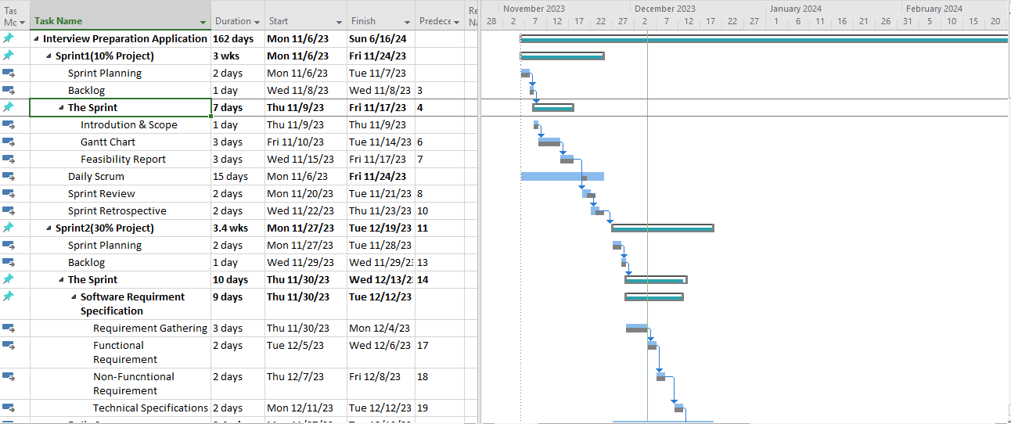

**References**

1. <https://link.springer.com/chapter/10.1007/978-3-540-69858-6_28>
2. <https://www.osti.gov/biblio/10183064>
3. <https://etrr.springeropen.com/articles/10.1007/s12544-010-0030-5>